8-7

Main Question (สำหรับแสดงข้อสอบ)

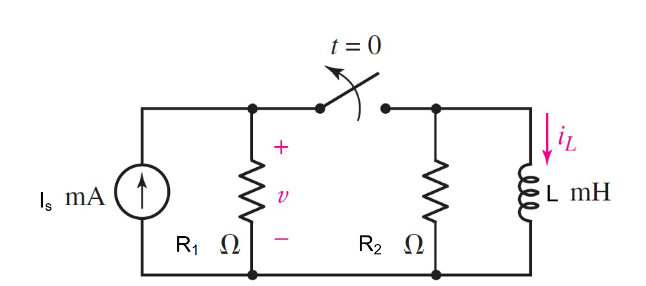

Given*is* = 4 mA, *R*1 = 300 Ω, *R*2 = 220 Ω, L= 2 mH.

Find

Variables (สำหรับเขียนโค้ดเพื่อหาคำตอบ)

Random variables

is = {1e-3:5e-3:1e-3};

r1 = {100:500:100};

r2 = {100:500:50};

l = {1e-3:3e-3:1e-3};

time = {1:5};

**Global variables**

#is = 4/1000; r1 = 300; r2= 220; l = 2/1000;

il0 = is;

req = r2;

tau = l/req;

ilt = il0*exp(-time/tau);

Part (กรอกคำตอบ)

1. *iL*(0-) = il0 = 4 mA

2. *iL*(0+) = il0 = 4 mA

3. *τ* = tau = 9.09x10-6 s

At *t* > 0

4. *iL*(*t*) = il0*exp(-t/tau) = 4*exp^(-t/9.09x10-6) mA

5. *iL*(time) = ilt = 0.7 mA *# time (15.8* µs*)*

8-8

Main Question (สำหรับแสดงข้อสอบ)



Given*Is* = 4 mA, *R*1 = 300 Ω, *R*2 = 220 Ω, L= 2 mH.

Find

Variables (สำหรับเขียนโค้ดเพื่อหาคำตอบ)

Random variables

Is = {1e-3:5e-3:1e-3};

r1 = {100:500:100};

r2 = {100:500:50};

l = {1e-3:3e-3:1e-3};

time = {1:5};

Global variables

#is = 4/1000; r1 = 300; r2= 220; l = 2/1000;

v0- = 0

v0+ = is* r1

il0 = is;

req = r2;

tau = l/req;

*#iL*(*t* )= il0*exp^(-t/ τ)

ilt = il0*exp(-time/ tau);

*#w(t)* = 0.5*l* *iL*(*t* )* *iL*(*t* )

wt = 0.5*l*ilt*ilt;

Part (กรอกคำตอบ)

1. *v*(0-) = v0- = 0 V
2. *v*(0+) = v0+ = 1.2 mA
3. *τ* = tau = 9.09x10-6 s

At *t* > 0

1. *iL*(*t*) = il0*exp(-t/tau) = 4*exp^(-t/9.09x10-6) mA
2. *W*(time*τ*) =wt = 36x10-17 J *# time (80* µs*)*

8-9

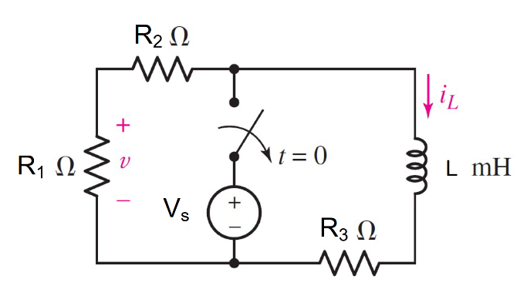

Given*Vs* = 10 V, *R*1 = 25 Ω, *R*2 = 10 Ω,

*R*3 = 50 Ω, L= 40 mH.

Find

Variables (สำหรับเขียนโค้ดเพื่อหาคำตอบ)

Random variables

r1 = {5:50:5}

r2 = {5:50:5}

r3 = {5:50:5}

l = {10e-3:50e-3:10e-3}

Vs = {2:10:2}.

time = {10e-6:500e-6:10e-6}

Global variables

#Vs =10; r1 = 25; r2= 10; r3= 50;

l = 40/1000;

v0n = (r1/(r1+r2))*Vs;

il0 = Vs/r3;

v0p = il0* r1

req = r1+r2+r3;

tau = l/req

ilt = il0*exp(-time/ tau);

vt = v0p*exp^(-time/ tau);

Part (กรอกคำตอบ)

1. *iL (t) =* il0*exp^(-t/ tau)

=**0.2*exp^(-85x102t/4) A**

1. *v(t) =* v0p*exp^(-t/ tau)

=**5*exp^(-85x102t/4) V**

1. *v(0-) =* v0n *=*7.142 V
2. *v(0+) =* v0p = 5 V
3. *iL(0-) =* il0 =0.2 A
4. *iL(0+) =* il0 = 0.2 A
5. *v(time)* = vt =1.84 V. *# time (470* µs*)*
6. *iL*(*time*) = ilt =73.6mA *# time (470* µs*)*

8.28

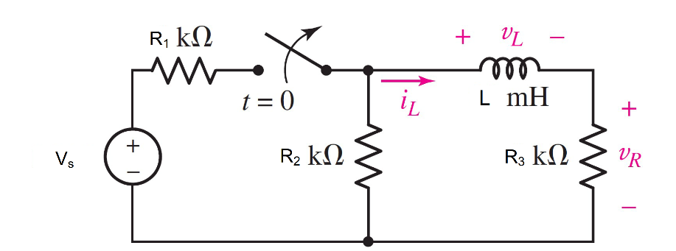

Given *Vs* = 1.2 V, *R*1 = 1000 Ω, *R*2 =1000 Ω, *R*3 = 2000 Ω, L= 30 mH

Find

Variables (สำหรับเขียนโค้ดเพื่อหาคำตอบ)

Random variables

r1 = {1000:2000:100}

r2 = {1000:2000:100}

r3 = {1000:2000:100}

l = {10e-3:50e-3:10e-3}

Vs= {1:5:0.1}.

time = {1e-6:10e-6:1e-6};

**Global variables**

#Vs =10; r1 = 25; r2= 10; r3= 50;

l = 40/1000;

#for t<0

vl0n = 0 ;

r23 = (r2*r3/r2+r3);

vr0n = (r23/(r23+r1)) * Vs ;

il0 = vr0n/r3;

#for t>0

vr0p = il0*r3;

vl0p = -il0*(r2+r3);

req=r2+r3;

tau = l/req;

ilt = il0*exp^(-time/tau);

Part (กรอกคำตอบ)

1. *vL(0-) = vl0n* = 0 V
2. *vR(0-) =vr0n = 0.48* V
3. *iL(0-) =* il0 =0.24 mA
4. *vL(0+) =* vl0p *=*-0.72 V
5. *vR(0+) =* vr0p = 0.48 V
6. *iL(0+) =* il0 = 0.24 mA
7. *iL (t) =* il0*exp^(-t/ tau)  
   = 0.24*exp^(-105t) mA
8. *iL*(*time*) = ilt =0.217 mA*# time (1* µs*)*

8.4-29

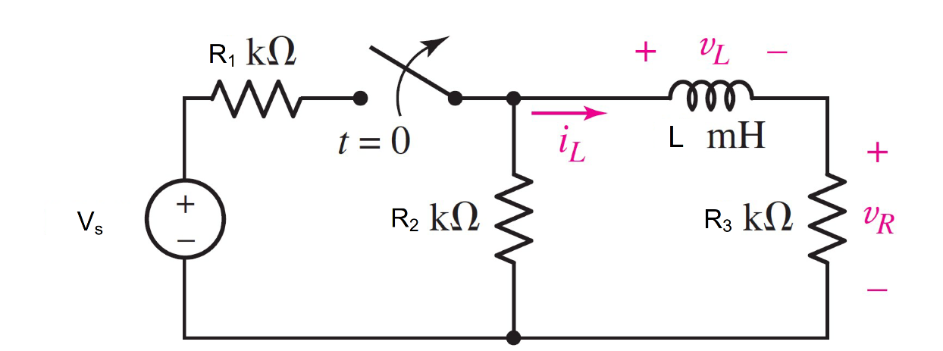

Given *Is* = 5 A, *R*1 = 8 Ω, *R*2 = 3 Ω, *R*3 = 2 Ω, L1= 3H, L2= 1H,L3= 2H

Find

**Random variables**

r1 = {1:10:1}

r2 = {1:10:1}

r3 = {1:10:1}

l1 = {1:10:1}

l2 = {1:10:1}

l3 = {1:10:1}

Is = {1:5:1}.

Global variables

#Is =5; r1 = 8; r2= 3; r3 = 2; l1=1; l2=1; l3=2;

#for t<0

il0 = (r2/r2+r3)*I;

i1n = I- il0;

#for t>0

i1p = -il0;

rt=(r2*r3)/(r2+r3);

I = (r1/rt+r1)*Is;

req=r2+r3;

leq = (l2*l3/l2+l3)+l1;

tau = Leq/Req;

Part (กรอกคำตอบ)

1. *iL(0-) = il0* = 2.608 A
2. *i1(0-) =i1n =* 1.739 A
3. iL(t) = il0*exp(-t/tau)   
   =2.608*exp^(-t/0.733) A
4. i1(t) = ilp*exp(-t/tau)

=-2.608*exp^(-t/0.733) A